The Kazakhstan National Formulary

Press Briefing

Contents:
- Key definitions
- The benefits of the Kazakhstan National Formulary
- About the Kazakhstan National Formulary
- Images for press use
- Further contact information

Key Definitions

Clinical Decision Making: the use of existing knowledge and information to select an evidence-based choice of action to treat a patient.
Digital Formulary: a list of medicines approved for use in the healthcare system by authorised prescribers which include information such as: indications, dosage, length of treatment, interactions, precautions, and contraindications which is available in a digital format, usually online via mobile or desktop technology which allows it to be easily searched and used at point of care.
Evidence-based Medicine: an approach to medical practice intended to optimise decision making by emphasising the use of evidence from well designed and conducted research.
Formulary: a list of medicines approved for use in the healthcare system by authorised prescribers which include information such as: indications, dosage, length of treatment, interactions, precautions, and contraindications.
Formulary System: a system of periodically evaluating and selecting medicines for the formulary, maintaining the formulary, gaining feedback from practicing healthcare professionals, and providing information in a suitable manual or list.
The Kazakhstan National Formulary (KNF): a government approved digital formulary made for Kazakhstan by International and Kazakhstan experts.
Point of Care: when clinicians and healthcare professionals deliver healthcare products, services and medicines to the patient.

The benefits of the Kazakhstan National Formulary (KNF)

A National Formulary is a reference which contains medical information to help with the safe and effective selection and use of medicines. As a national formulary, the KNF will:
- Improve patient outcomes by sharing the latest evidence of best practice.
- Give clear guidance of what medicines are approved for use by the government and medical bodies.
- Help remove variations in care between regions, hospitals and individual healthcare professionals.
- Aid in controlling the number of adverse drug reactions.
- Keep healthcare professionals up to date with the latest medicines.
- Provides support at key clinical decision making points.
- Helps control medical budgets and stock through the rational use of medicines.

Benefits to the Patient
National Formularies have a really positive effect on anyone who needs medical care. The KNF will:
- Improve patient outcomes and safety.
- Help reduce bad reactions to the medicines.
- Ensure that patients receive the same care wherever they are treated in Kazakhstan.
- Ensure patients will be offered the best suite of medicines, including the most up to date drugs as recommended within the KNF.
- Gives peace of mind that all medicines prescribed are checked by experts and approved by the government.

Benefits to the Doctors and Hospitals
National Formularies are a great resource and aid for medical professionals and anyone working within the medical system. The KNF will:
- Give easily accessible information at point of care to support clinical decision making.
- Give more confidence in prescribing according to latest evidence.
- Help keep healthcare professionals up to date with the latest medicines.
- Ensure all medicines are government approved.
- Make adverse drug reactions (ADRs) easier to manage.
- Create easier dispensing within the pharmacy.
- Support easiest procurement for hospitals through rationalised medicines lists.
- Give a clear and consistent approach to treatment across all healthcare professionals and organisations.

Benefits to the Government
National Formularies can also have a national influence. The KNF will:
- Improve standards of care across Kazakhstan.
- Give clear guidance of what medicines are approved for use by the doctors and hospitals.
- Help remove variations in care between regions, hospitals and individual healthcare professionals.
- Make sure all clinics and hospitals are using the best evidence available.
- Improve the reputation of Kazakhstan against International comparators.
- Improve the lives of the people of Kazakhstan.

About the Kazakhstan National Formulary

The Kazakhstan National Formulary has been created by EBN Health in partnership with the Ministry of Healthcare and Social Development to provide access to the latest up-to-date, approved and effective prescribing information to improve healthcare for patients, doctors and the healthcare system as a whole.
Containing information on all the approved medicines for prescription within Kazakhstan, the KNF is hosted on a government-owned database and can be accessed through any online connection. Not only are all of the currently available evidence-based medicines listed, but processes have been implemented and an editorial team created and trained to assess new medicines going forwards. The KNF provides a future-proof, bespoke solution for Kazakhstan and takes into account national prescribing practices and local evidence-based medicine experiences.
The KNF has a digitally responsive online design to ensure it can be navigated easily on both desktops and mobile technology such as smartphones and tablets. This means it can be used anywhere at a point of clinical decision making to help remove variations in care and improve healthcare for the patient and the prescribing professional.
The KNF can be accessed at www.knf.kz.

How did it begin?
The aim of the KNF was simple: the Kazakhstan Ministry of Healthcare and Social Development wished to improve patient care and prescribing doctors’ knowledge through having the latest high quality and peer reviewed information at point of care.
Ministers wanted a bespoke solution that would take on board national practices and be able to be tailored to the exact needs of Kazakhstan healthcare professionals, their patients, and the overall healthcare system. This approach was supported and advised by The World Bank.
EBN Health were chosen to assist due to its outstanding end-to-end service offering, from planning, creation and development all the way through to launch and post-launch support. This has been achieved within a year of the project starting.

Creating the KNF
The KNF is unique in that the structure is based on the International Anatomical Therapeutic Chemical (ATC) classification system. KNF drug monographs can therefore be linked directly to other sources including registration documents and WHO information. We believe this is the first time a national formulary has been constructed this way, and ensures not only high quality additions, but ensures the rational use of medicines. The KNF is therefore the most advanced source of evidence-based information for healthcare in central Asia, if not the world.
The backbone of the rest of the information within the KNF was drawn from a number of high quality and reliable sources, including:
- Licenced Medicines Information as submitted by the pharmaceutical companies to the Kazakhstan Government
- World Health Organisation (WHO)
- National Institute for Clinical Excellence (NICE) from the United Kingdom
- Cochrane Institute
To keep the KNF as up to date as possible, there is a talented editorial team consisting of Kazakh medical professionals who have been trained to develop the KNF further, adding new medicines, and refining and improving the information available. This editorial team is advised by a group of experts from across Kazakhstan with specialist knowledge of particular medical areas such as haematology and paediatrics.

The KNF as a Digital Resource
The KNF is available digitally at www.knf.kz.
It has been developed with a Kazakh company to ensure a seamless use of the latest digital publishing technology. Created with a responsive design to ensure it can be navigated easily on both desktops and mobile technology such as smartphones and tablets, it can be used anywhere at a point of clinical decision making.
The KNF database is hosted by The Republican Centre for Health Development ensuring that complete control of the formulary rests within the country and within the government.

Training and Communications
In order to help ensure that the KNF will be fully adopted over the course of 2016, EBN Health is committed to a training programme for healthcare professionals across the country, and aiding with countrywide communications alongside the local KNF Team. In addition, work is underway to incorporate the use of the KNF in medical and pharmacy education with all of the universities within Kazakhstan.

The KNF Today
The KNF is an active, living database which is constantly being checked and updated for new and existing medicines. This will allow the best clinical decision making at point of care. It has already been listed as one of the top 14 healthcare initiatives from 2015 by the Ministry of Healthcare and Social Development.
Future development will include refining the information based on new evidence, expanding the list of medicines covered, reviewing new medicines, and covering the needs of professionals when treating children.
It is also hoped that KNF will provide the central resource in a much larger health information portal for all healthcare staff, and play an important role in educating new clinical staff and will be fundamental to professional development throughout their careers.

Images for press use

EBN Health logo

KNF logo

The KNF
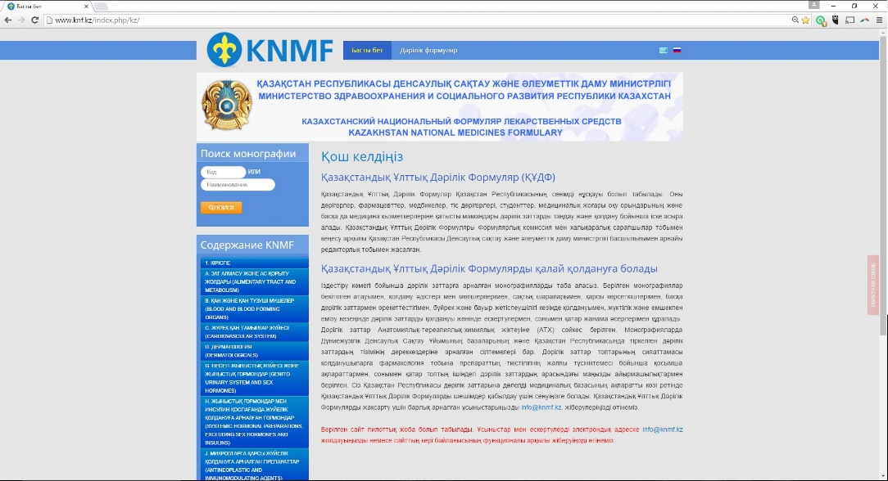

Duncan Enright, Managing Director, EBN Health

Further contact information

About EBN
EBN is a group of highly skilled experts in clinical practice and digital publishing who aim to bring knowledge, capabilities and real products to your healthcare system. EBN is the brainchild of Duncan Enright, who ran the British National Formulary for 5 years, is a founder Director of the New Zealand National Formulary, has been a non-executive director in the British NHS for over 10 years, and has over 30 years’ experience in publishing. Based in Oxfordshire in the UK, EBN has a global reach and has been involved in projects in a variety of countries including in Australasia and Central Asia.
For further Information on EBN Health, contact:
Email: info@ebnhealth.com
Telephone: +44 (0)1865 522326
Post:
Witney Business and Innovation Centre
Windrush Park Road
Witney, Oxfordshire OX29 7DX
UK
Website: www.EBNHealth.com

